**Numbers used in Programming:**

1. **Unique Number:-**

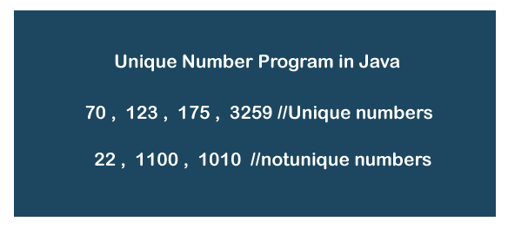The number will be unique if it is positive integer and there are no repeated digits in the number. In other words, a number is said to be unique if and only if the digits are not duplicate. For example, 20, 56, 9863, 145, etc. are the unique numbers while 33, 121, 900, 1010, etc. are not unique numbers.

1. 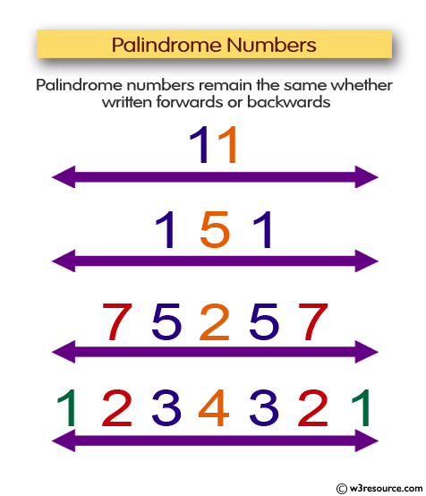**Palindrome Number:-**
2. 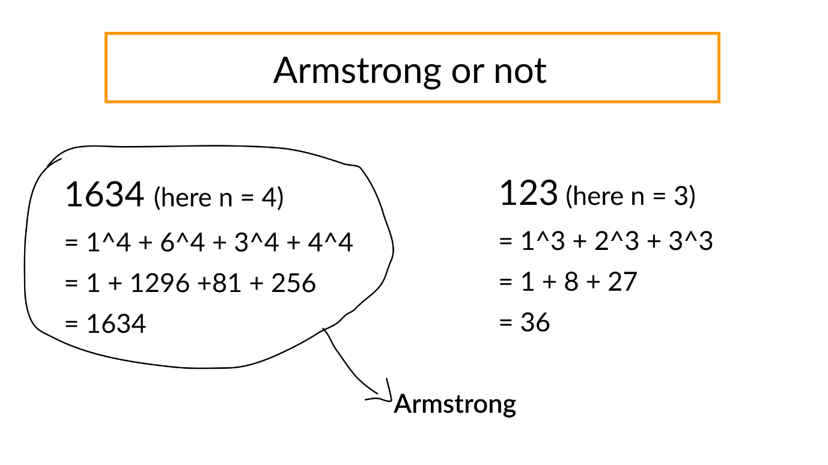**Armstrong number:-**
3. **Krishnamurthy number:-**

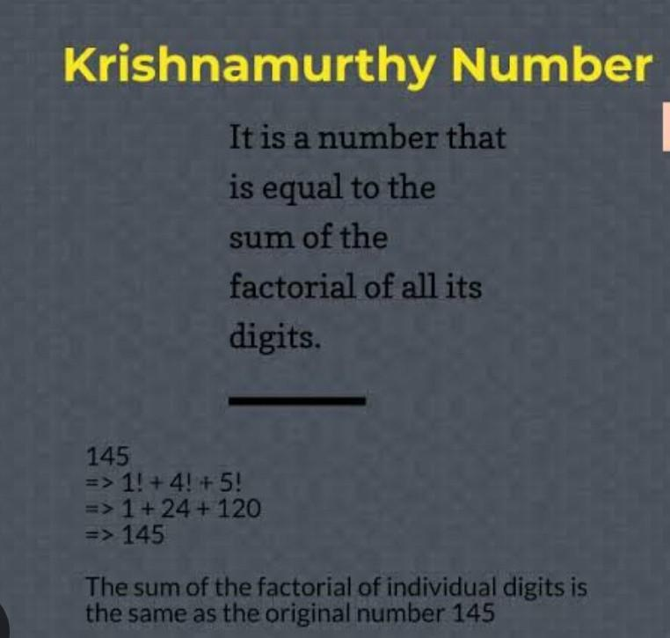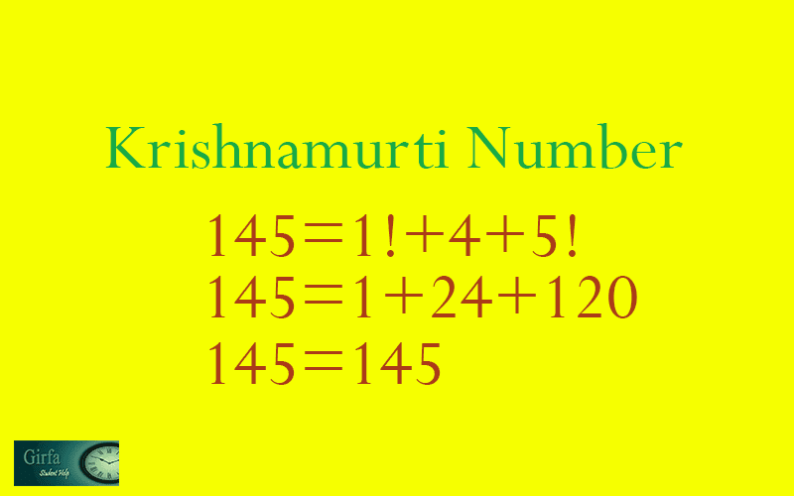

1. 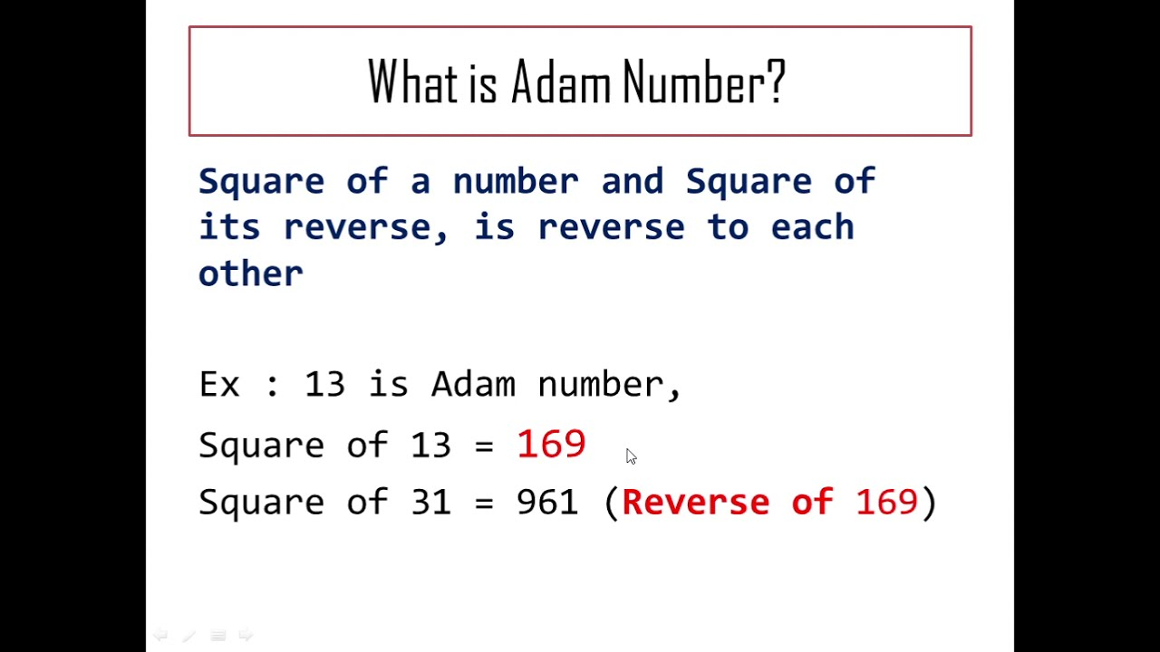**Adom Number:-**
2. **Digo Prime Number:**

**If each digit of a prime number is also prime then the prime number is called digo prime.**

1. 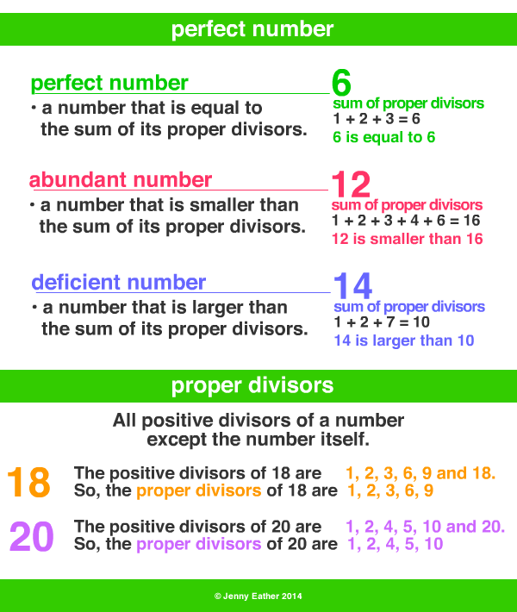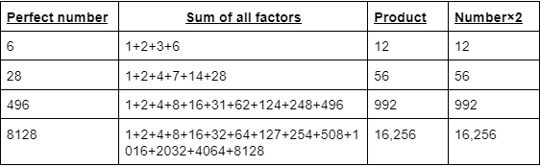**Perfect Number:-**

